Ideation Phase
Empathize & Discover

Date | 30/09/2026
Team ID | 6ab3d79c6603573ccfb36fe0
Project Name | AI FitTrack
Maximum Marks | 4 Marks

Empathy Map Canvas – FitSense
The FitSense system focuses on understanding the needs and expectations of fitness users. Users want a simple and personalized fitness solution that can provide suitable workout recommendations according to their fitness goals, activity level, and preferences.
Users think about choosing the right exercises and maintaining a proper fitness routine. They may feel confused when general workout plans do not match their individual requirements. They want clear guidance that helps them understand which workouts are suitable for them.
Users select their fitness goals, provide their personal fitness information, and follow the recommended workouts. They may also check their progress and use the system regularly to maintain their fitness routine.
The main problems faced by users are difficulty in selecting suitable workouts, lack of personalized guidance, and limited knowledge about which exercises match their needs. These challenges can make fitness planning difficult.
FitSense addresses these needs by using Artificial Intelligence to provide personalized fitness recommendations. It helps users choose suitable workouts, plan their fitness routine easily, and receive recommendations based on their individual requirements.

Example:
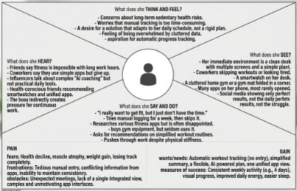

Example: Food Ordering & Delivery

